Cloud Run - httpbin

<https://httpbin.org/> to verify http requests and or generate http responses.

Httpbin is a very popular tool.

Purpose of this exercise is to deploy our own httpbin service on Cloud Run.

There are plenty of implementations available on Github with Dockerfile to generate your own image.

In this exercise however you are going to deploy an existing Docker image on Cloud Run. The image to be deployed is kong/httpbin available on Docker Hub.

**Step 1: clone the image locally**

| *Enter command(s) you executed.* |
| --- |
| docker pull kong/httpbin |

**Step 2: tag the local image**

| *Enter command(s) you executed.* |
| --- |
| docker tag kong/httpbin europe-west1-docker.pkg.dev/infra3-rucka-rostislav/httpbin/httpbin |

**Step 3: upload to Google Artefact repository**

*Auth* <https://cloud.google.com/artifact-registry/docs/docker/authentication>

| *Enter command(s) you executed.* |
| --- |
| gcloud auth login  gcloud auth configure-docker europe-west1-docker.pkg.dev  docker push europe-west1-docker.pkg.dev/infra3-rucka-rostislav/httpbin/httpbin |

**Step 4: Deploy the httpbin service on Cloud run**

| *Enter command(s) you executed.* |
| --- |
| gcloud run deploy httpbin --image europe-west1-docker.pkg.dev/infra3-rucka-rostislav/httpbin/httpbin –region=europe-west1 –port=80  gcloud run services add-iam-policy-binding httpbin --member="allUsers" --role=roles/run.invoker --region=europe-west1 |
| *Enter link to your newly deployed Cloud Run service.* |
| <https://httpbin-2ho63ruxga-ew.a.run.app/> |

**Step 5: Show service working**

Test the service and show it is working.

*Show result of curl http://<your-httpbin-service>/ip.*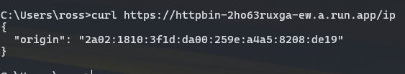

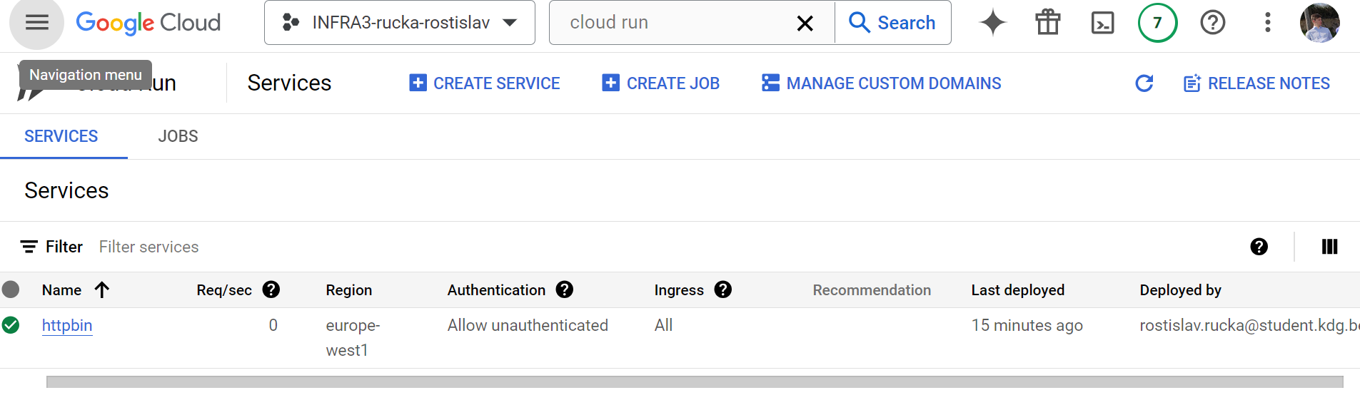

| *Add screenshot of your service deployed in your Google Cloud console.* |
| --- |
|  |
| *Add any information you think is relevant.* |
|  |

**PLEASE LEAVE YOUR SERVICE RUNNING FOR REVIEW.**